LAP PROGRAM 1

Develop a Java program that prints all real solutions to the quadratic equation ax2 +bx+c = 0. Read in a, b, c and use the quadratic formula. If the discriminate b2-4ac is negative, display a message stating that there are no real solutions.

|  |
| --- |
| import java.util.Scanner; |
|  |  |
|  | public class QuadPro { |
|  | public static void main(String[] args) { |
|  | double t1,t2; |
|  | Scanner sc = new Scanner(System.in); |
|  | System.out.println("Enter a,b,c value:\t"); |
|  | double a = sc.nextDouble(); |
|  | double b = sc.nextDouble(); |
|  | double c = sc.nextDouble(); |
|  | double D = b*b-4*a*c; |
|  | if(D<0) { |
|  | System.out.println("there are no real solution"); |
|  | } |
|  | else { |
|  | t1 = (-b+Math.sqrt(D))/2*a; |
|  | t2 = (-b-Math.sqrt(D))/2*a; |
|  | System.out.println("real root1: "+t1); |
|  | System.out.println("real root2: "+t2); |
|  | } |
|  |  |
|  | } |
|  | } |

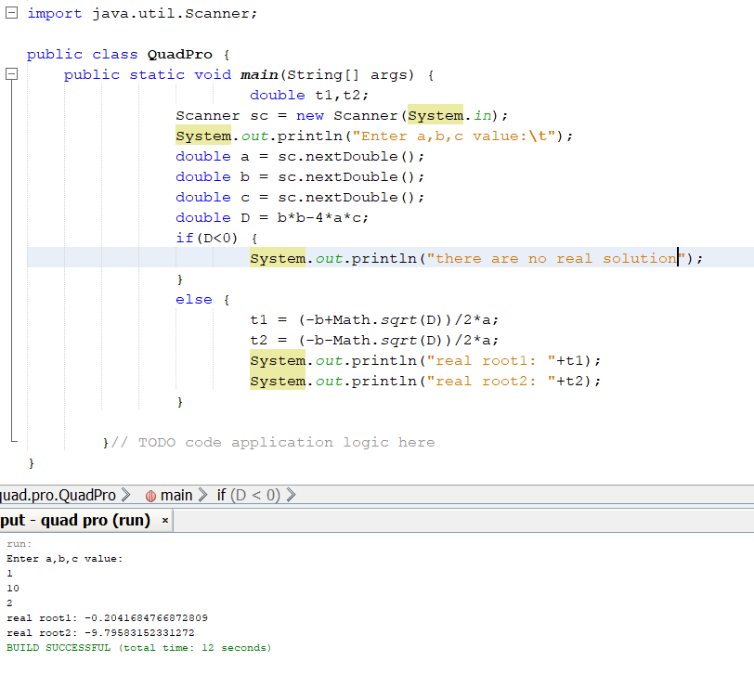

LAP PROGRAM 2

Develop a Java program to create a class **Student** with members **usn, name**, **an array  credits** and **an array marks**. Include methods to accept and display details and a method to  calculate SGPA of a student

|  |
| --- |
| import java.util.Scanner; |
|  |  |
|  |  |
|  | class Student |
|  | { |
|  | private String USN; |
|  | private String name; |
|  | private int n; |
|  | private double SGPA = 0; |
|  | private int totalCredits = 0; |
|  | Scanner ss = new Scanner(System.in); |
|  |  |
|  | void Details() |
|  | { |
|  | System.out.println("Enter USN of the student"); |
|  | USN = ss.nextLine(); |
|  | System.out.println("Enter Name of the student"); |
|  | name = ss.nextLine(); |
|  | System.out.println("Enter no of subjects"); |
|  | n = ss.nextInt(); |
|  | int credits[] = new int[n]; |
|  | double marks[] = new double[n]; |
|  | System.out.println("Enter details of the subjects:"); |
|  | for(int i=0;i<n;i++) |
|  | { |
|  | System.out.println("Enter credits allotted to the subject "+(i+1)); |
|  | credits[i] = ss.nextInt(); |
|  | System.out.println("Enter marks in the subject "+(i+1)); |
|  | marks[i] = ss.nextInt(); |
|  | Calculate(credits[i],marks[i],i); |
|  | } |
|  | } |
|  | void Calculate(int credit,double mark,int j) |
|  | { |
|  | totalCredits = totalCredits + credit; |
|  | if(mark>=90&&mark<=100) |
|  | SGPA = SGPA + (10*credit); |
|  | else if(mark>=80 && mark<=89) |
|  | SGPA = SGPA + (9*credit); |
|  | else if(mark>=70&&mark<=79) |
|  | SGPA = SGPA + (8*credit); |
|  | else if(mark>=60&&mark<=69) |
|  | SGPA = SGPA + (7*credit); |
|  | else if(mark>=50 && mark<=59) |
|  | SGPA = SGPA + (6*credit); |
|  | else if(mark>=40&&mark<=49) |
|  | SGPA = SGPA + (5*credit); |
|  | else |
|  | System.out.println("Failed in ubject "+(j+1)); |
|  | } |
|  | void Display() |
|  | { |
|  | System.out.println("Details of the Student"); |
|  | System.out.println("Name :"+name); |
|  | System.out.println("USN: "+USN); |
|  | System.out.println("SGPA of student "+(SGPA/totalCredits)); |
|  | } |
|  | } |
|  | public class LapPro2 { |
|  | public static void main(String[] args) { |
|  | Student s1 = new Student(); |
|  | s1.Details(); |
|  | s1.Display(); // TODO code application logic here |
|  | } |
|  |  |
|  | } |

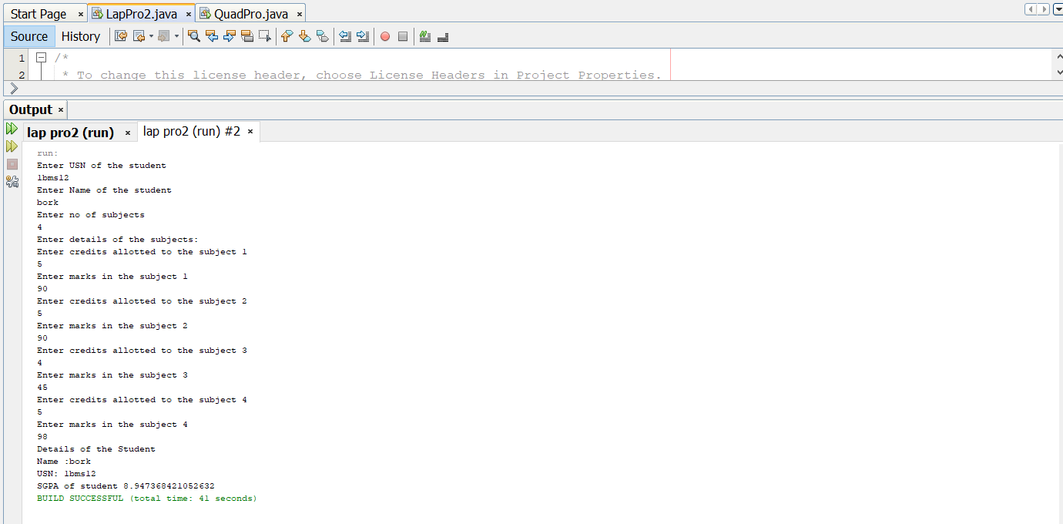

LAP PROGRAM 3

Create a class Book which contains four members: name, author, price, num_pages. Include a constructor to set the values for the members. Include methods to set and get the details of the objects. Include a toString( ) method that could display the complete details of the book. Develop a Java program to create n book objects.

|  |
| --- |
| import java.util.Scanner; |
|  |  |
|  | class Books{ |
|  | Scanner sc=new Scanner(System.in); |
|  | int num_pages; |
|  | float price; |
|  | String name,author; |
|  | Books(String n,String a, int num,float p) |
|  | { |
|  | name=n; |
|  | author=a; |
|  | num_pages=num; |
|  | price=p; |
|  |  |
|  | } |
|  | public String toString() |
|  | { |
|  | return("\nName: "+name+"\nAuthor: "+author+"\nNumber of pages: "+num_pages+"\nPrice: "+price); |
|  | } |
|  |  |
|  |  |
|  | } |
|  | public class JavaApplication8 { |
|  | public static void main(String args[]) |
|  | { |
|  | int n; |
|  | Scanner sc=new Scanner(System.in); |
|  | System.out.println("Enter the number of Books: "); |
|  | n=sc.nextInt(); |
|  | Books arr[]=new Books[n]; |
|  | for(int i=0;i<n;++i) |
|  | { |
|  | String name,a; |
|  | int num; |
|  | float p; |
|  | System.out.println("\nEnter the name of the book "+(i+1)+": "); |
|  | name=sc.next(); |
|  | System.out.println("Enter the name of author of the book: "); |
|  | a=sc.next(); |
|  | System.out.println("Enter the number of pages of the book: "); |
|  | num=sc.nextInt(); |
|  | System.out.println("Enter the price of the book: "); |
|  | p=sc.nextFloat(); |
|  | arr[i]=new Books(name,a,num,p); |
|  | System.out.println("Details of Book "+(i+1)+": "); |
|  | System.out.print(arr[i]); |
|  |  |
|  |  |
|  |  |
|  | } |
|  | } |
|  | } |

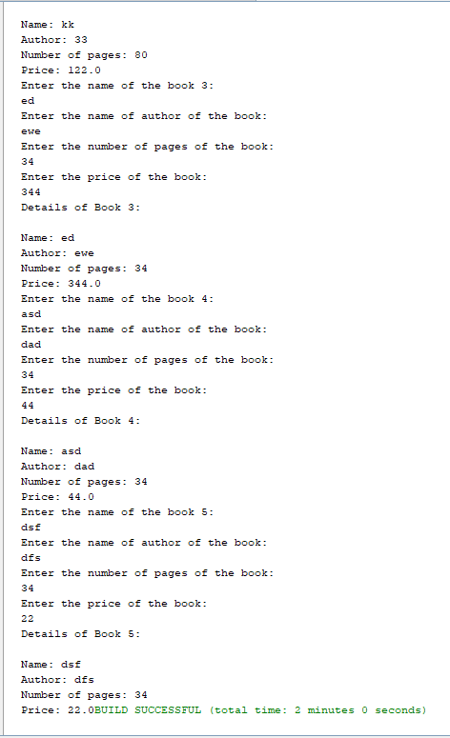

LAP PROGRAM 4

Develop a Java program to create an abstract class named Shape that contains two integers and an empty method named printArea( ). Provide three classes named Rectangle, Triangle and Circle such that each one of the classes extends the class Shape. Each one of the classes containonly the method printArea( ) that prints the area of the given shape.

package javaapplication7;

/**

*

* @author rohan siwach

*/abstract class shape

{

int a=3,b=4;

abstract public void print_area();

}

class rectangle extends shape

{

public int area_rect;

public void print_area()

{

area_rect=a*b;

System.out.println("The area of rectangle is:"+area_rect);

}

}

class triangle extends shape

{

int area_tri;

public void print_area()

{

area_tri=(int) (0.5*a*b);

System.out.println("The area of triangle is:"+area_tri);

}

}

class circle extends shape

{

int area_circle;

public void print_area()

{

area_circle=(int) (3.14*a*a);

System.out.println("The area of circle is:"+area_circle);

}

}

public class JavaApplication7 {

/**

* @param args the command line arguments

*/

public static void main(String[] args) {

rectangle r=new rectangle();

r.print_area();

triangle t=new triangle();

t.print_area();

circle r1=new circle();

r1.print_area();

}

}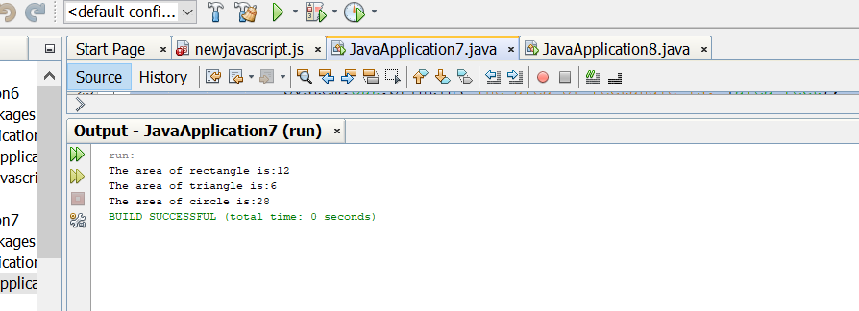

LAP PROGRAM 5

Develop a Java program to create a class Bank that maintains two kinds of account for its customers, one called savings account and the other current account. The savings account provides compound interest and withdrawal facilities but no cheque book facility. The current account provides cheque book facility but no interest. Current account holders should also maintain a minimum balance and if the balance falls below this level, a service charge is imposed. Create a class Account that stores customer name, account number and type of account. From this derive the classes Curr-acct and Sav-acct to make them more specific to their requirements. Include the necessary methods in order to achieve the following tasks: • Accept deposit from customer and update the balance. • Display the balance. • Compute and deposit interest • Permit withdrawal and update the balance • Check for the minimum balance, impose penalty if necessary and update the balance

package javaapplication10;

import java.util.Scanner;

class Bank

{

int deposit_balance;

int wthdraw_balance;

String customername;

String Account_Number;

String Account_Type;

int Balance=27800;

void accept()

{

Scanner s=new Scanner(System.in);

System.out.println("Enter the customer name\n");

customername=s.next();

System.out.println("Enter the Account Number\n");

Account_Number=s.next();

System.out.println("Enter the Account type\n");

Account_Type=s.next();

}

void display()

{

System.out.println("CUSTOMER NAME : "+customername);

System.out.println("ACCOUNT NUMBER : "+Account_Number);

System.out.println("ACCOUNT TYPE : "+Account_Type);

}

}

class curr_acct extends Bank{

int updated_balance;

int After_cwithdrawn;

int updated_lost_cbalance;

int cdepo_ba(){

updated_balance=Balance+deposit_balance;

return updated_balance;

}

int cwith_ba(){

After_cwithdrawn=((updated_balance)-(wthdraw_balance));

return After_cwithdrawn;

}

int minimum()

{

if((After_cwithdrawn)<=(2000))

{

updated_lost_cbalance=((After_cwithdrawn)-(200));

System.out.println("you have minimum balance below 2000 so u have lost 200 rs");

return updated_lost_cbalance;

}

else

return After_cwithdrawn;

}

}

class sav_acct extends Bank{

int supdated_balance;

int After_swithdrawn;

int updated_lost_sbalance;

int compound_interest;

int sdepo_ba(){

supdated_balance=Balance+deposit_balance;

return supdated_balance;

}

int interest()

{

double r=0.08;

int n=12;

int t=5;

compound_interest=(int)((supdated_balance)*(Math.pow((1+(r/n)),(n*t))));

return compound_interest;

}

int Swith_ba(){

After_swithdrawn=((compound_interest)-(wthdraw_balance));

return After_swithdrawn;

}

int minimum()

{

if((After_swithdrawn)<=(1000))

{

updated_lost_sbalance=((After_swithdrawn)-(100));

return updated_lost_sbalance;

}

else

return After_swithdrawn;

}

}

/**

*

* @author rohan siwach

*/

public class Transactions {

/**

* @param args the command line arguments

*/

public static void main(String[] args) {

Scanner r=new Scanner(System.in);

curr_acct CA=new curr_acct();

CA.accept();

System.out.println("Enter the money u want to deposit in current account in rupees");

CA.deposit_balance=r.nextInt();

CA.display();

System.out.println("After your deposition of "+CA.deposit_balance+"\nNow your total balance is RS-"+CA.cdepo_ba());

System.out.println("Enter the money you want to withdraw in rupees");

CA.wthdraw_balance=r.nextInt();

System.out.println("After your withdrawal of "+CA.wthdraw_balance+"\nNow your total balance is RS-"+CA.cwith_ba());

System.out.println("After checking if u have minimum balance are not your updated total balance is RS-"+CA.minimum());

sav_acct SA=new sav_acct();

SA.accept();

System.out.println("Enter the money u want to deposit in Saving account");

SA.deposit_balance=r.nextInt();

SA.display();

System.out.println("After your deposition of "+SA.deposit_balance+"\nNow your total balance is RS-"+SA.sdepo_ba());

System.out.println("After interest ur updated balance is RS-"+SA.interest());

System.out.println("Enter the money you want to withdraw in Saving account");

SA.wthdraw_balance=r.nextInt();

System.out.println("After your withdrawal of RS-"+SA.wthdraw_balance+"\nNow your total balance is RS-"+SA.Swith_ba());

System.out.println("After checking if u have minimum balance are not your updated total balance is RS-"+SA.minimum());

}

}